1. WAP to add key value pairs in hashmap

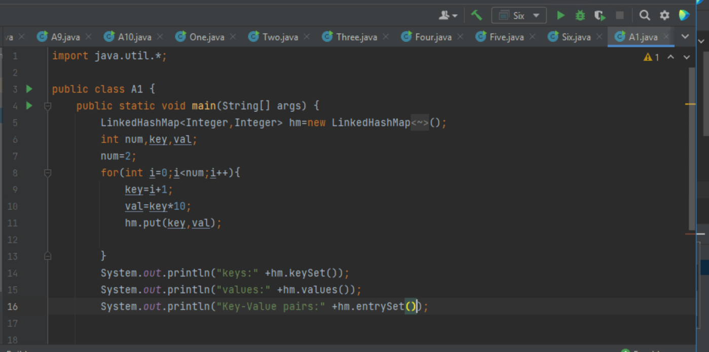

Output:

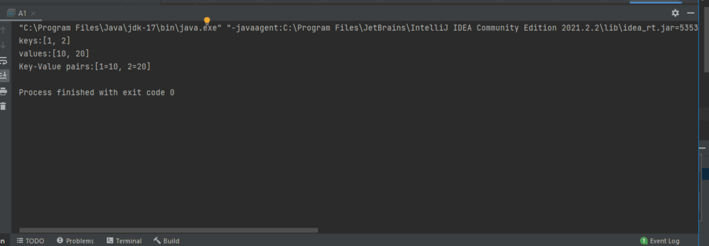

1. WAP to retrieve a value associaed with a agiven key from the hash map.

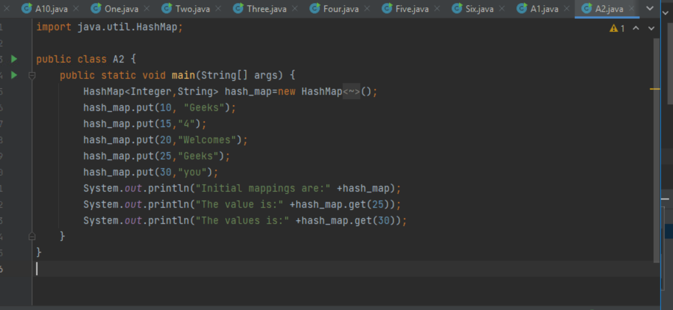

OUTPUT:

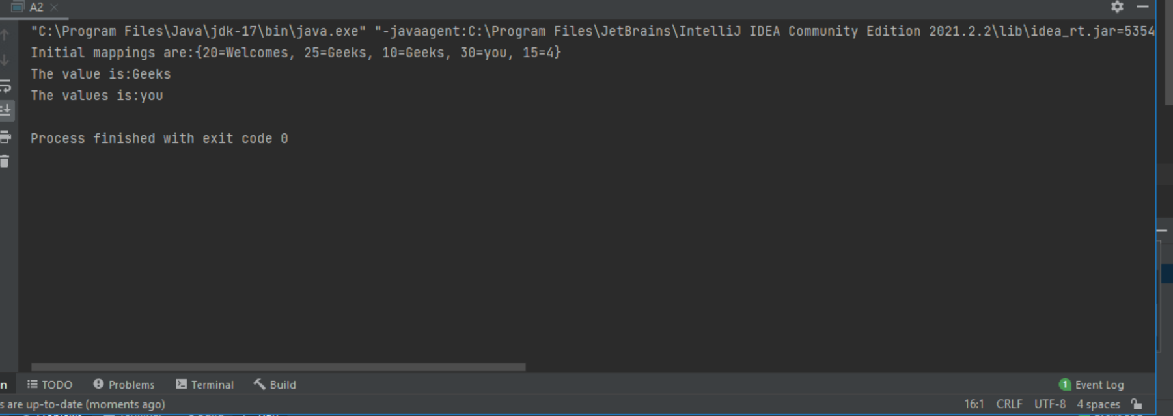

3.WAP to check whether a particular key value exist in HashMap or not.

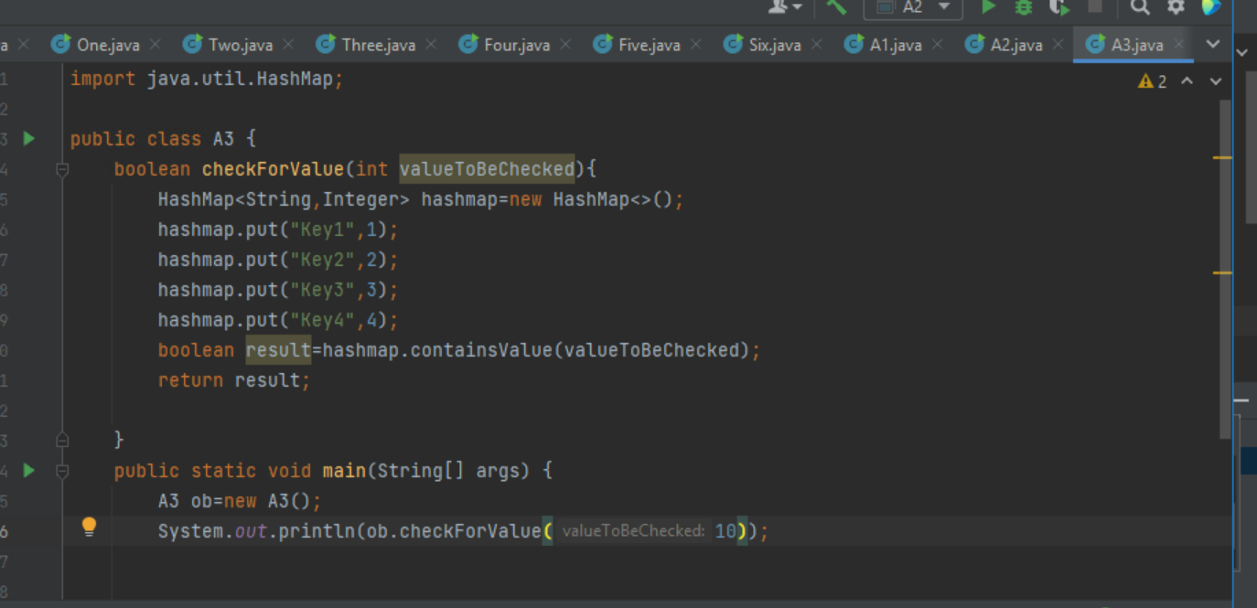

Output:

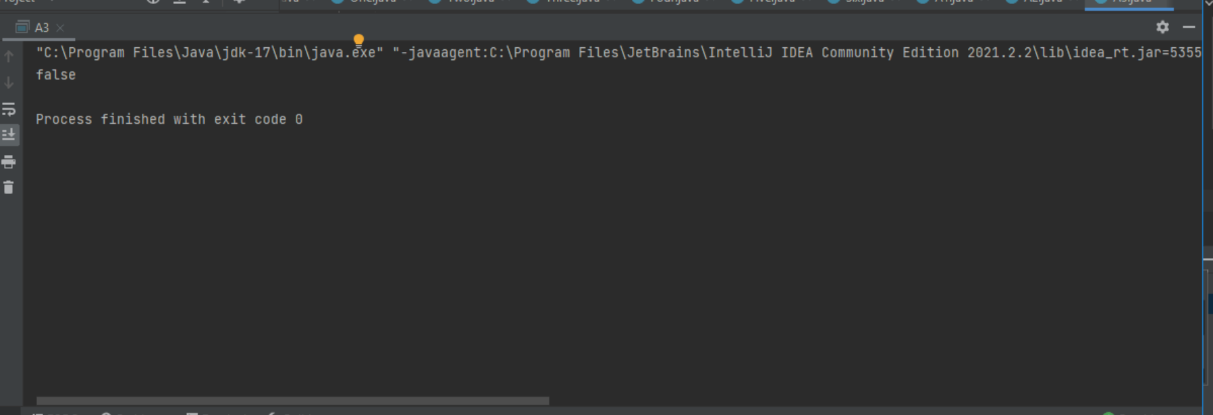

4.WAP to remove all the key value pairs from hashmap

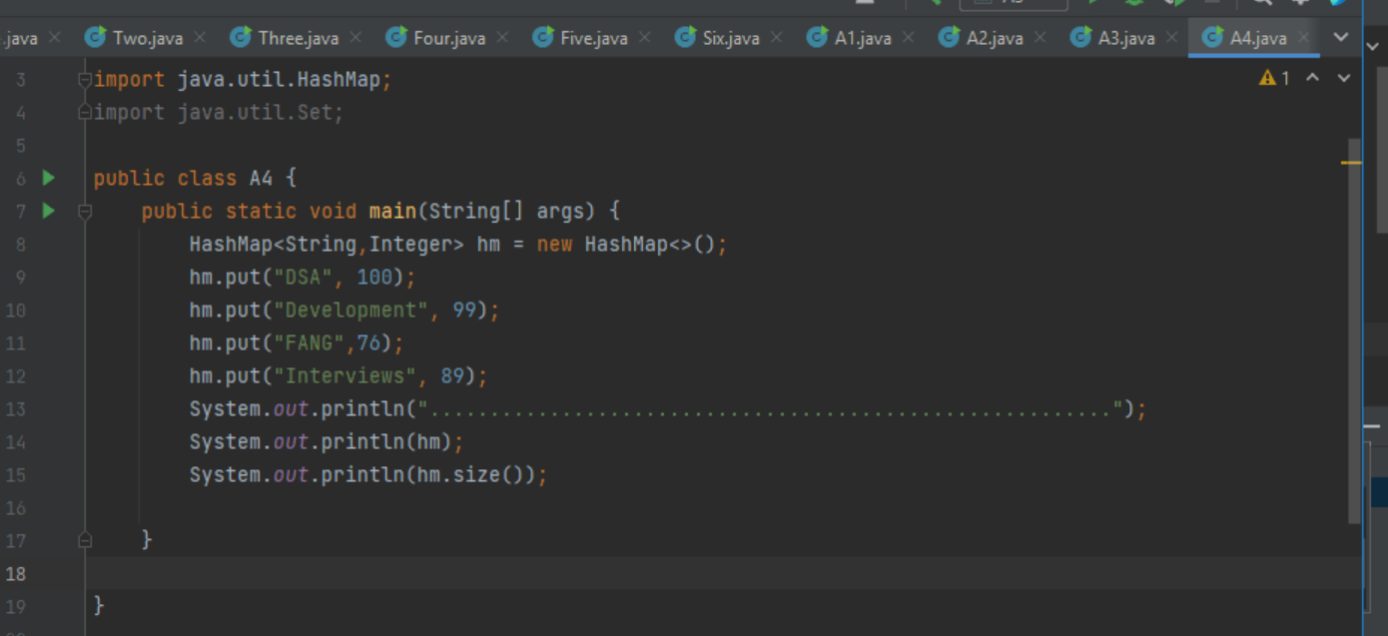

OUTPUT:

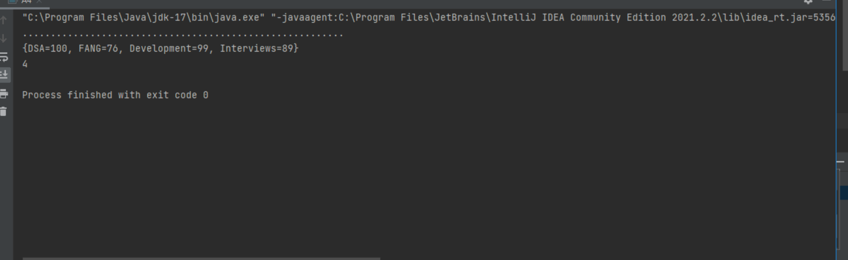

5.WAP to Clear Hashmap for reuse.

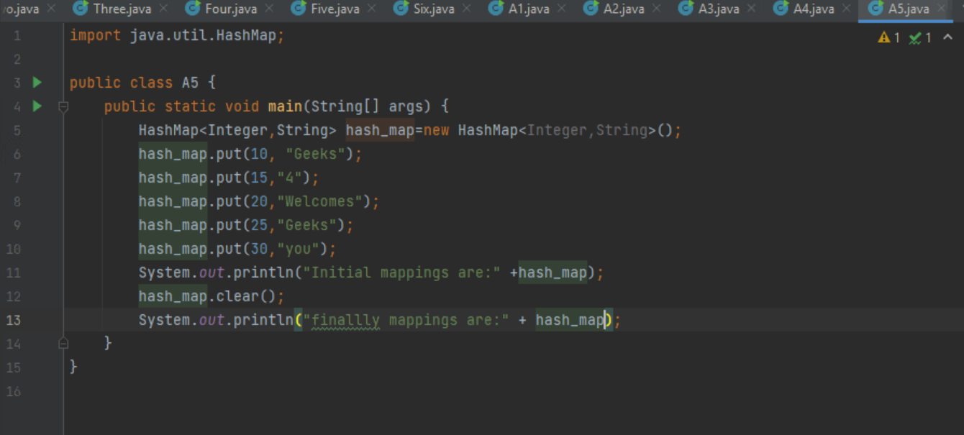

OUTPUT:

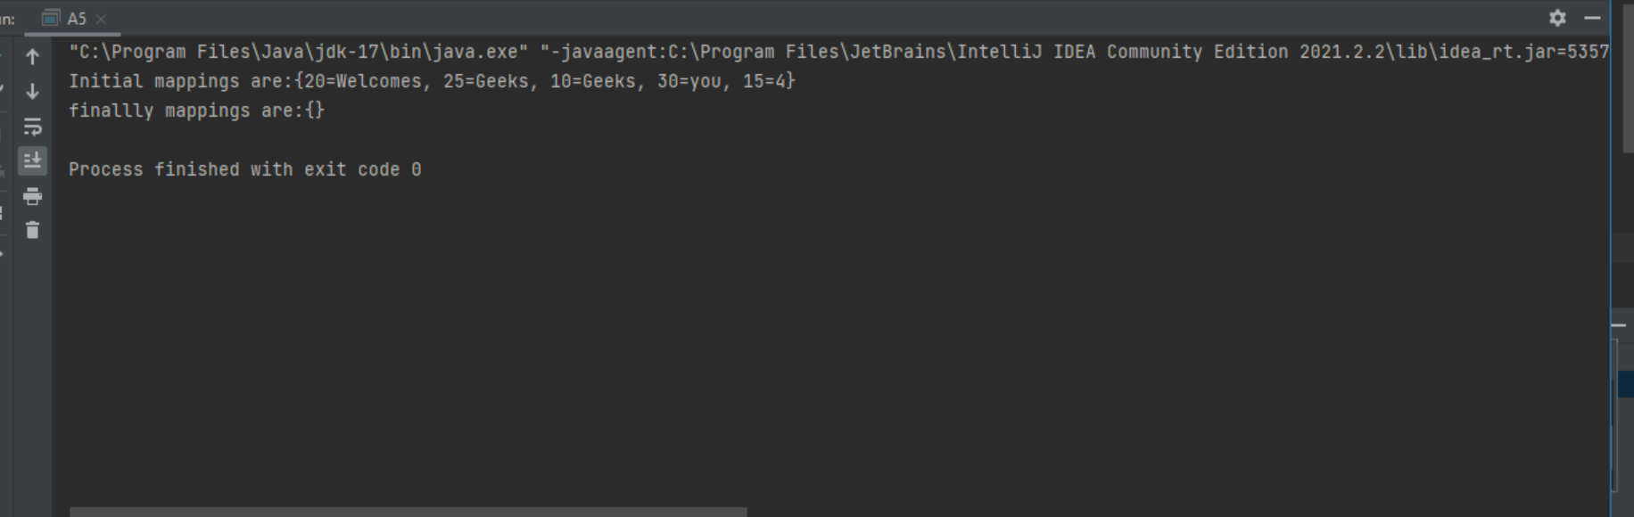

6. WAP to sort arraylist using collection sorting techniques.

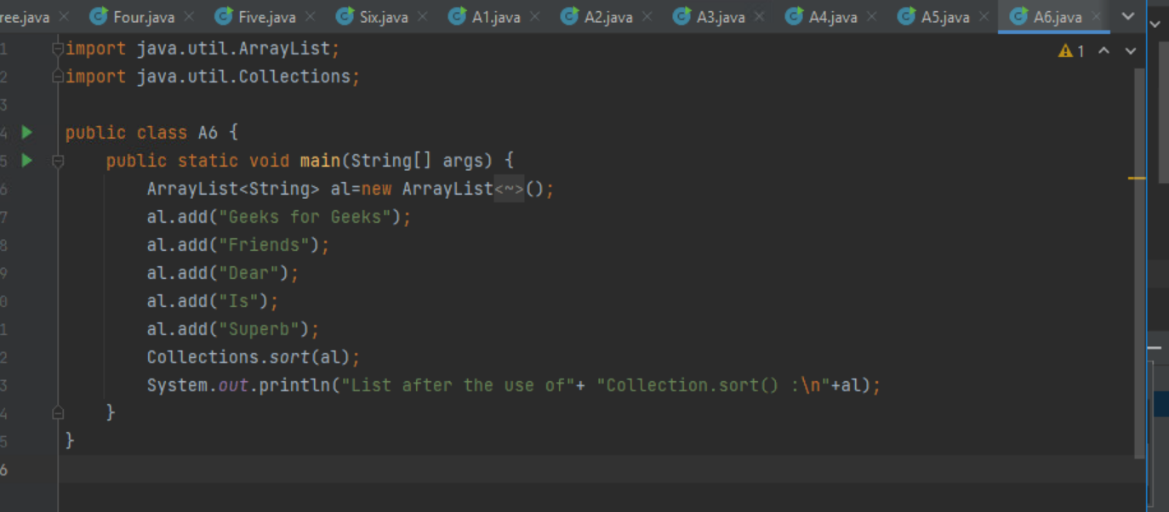

OUTPUT:

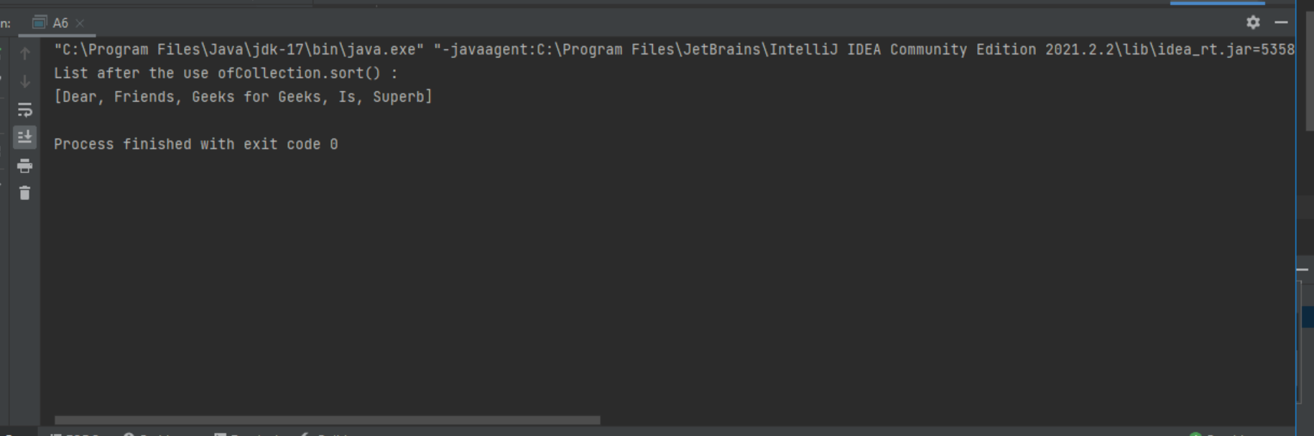

7. WAP to sort arrayLIst in ascending order.

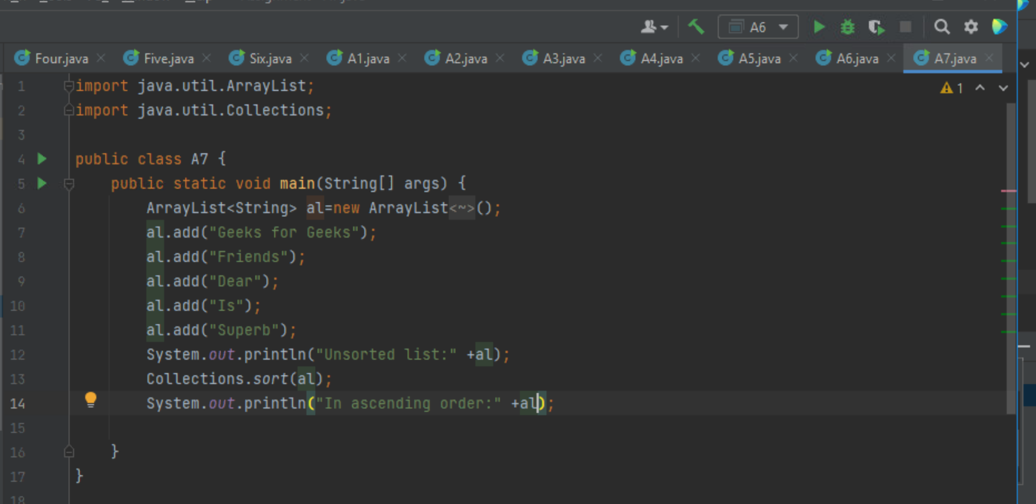

OUtPUT:

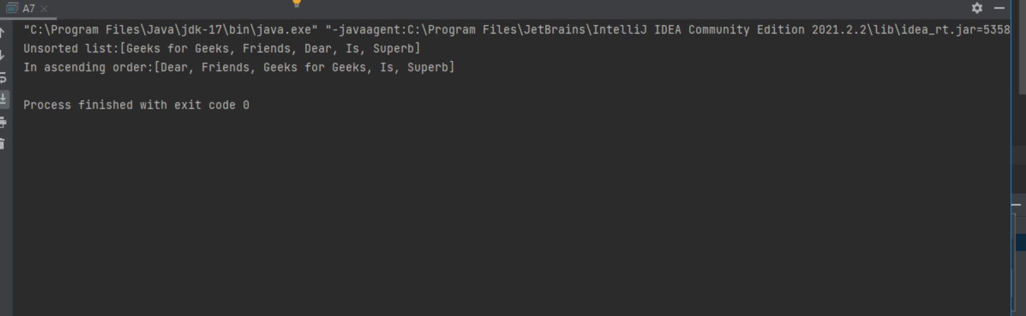

8.WAP to find the min and max values from the list using the collection class methods.

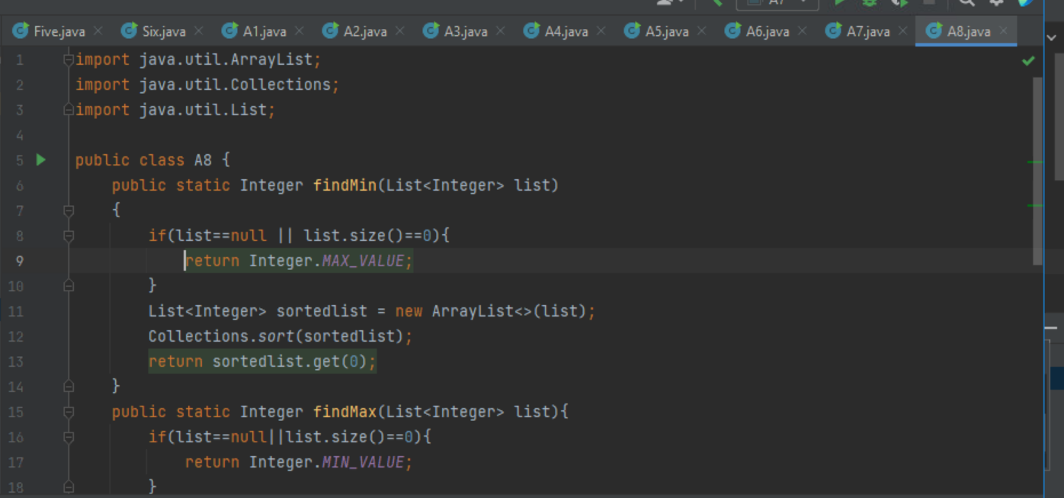

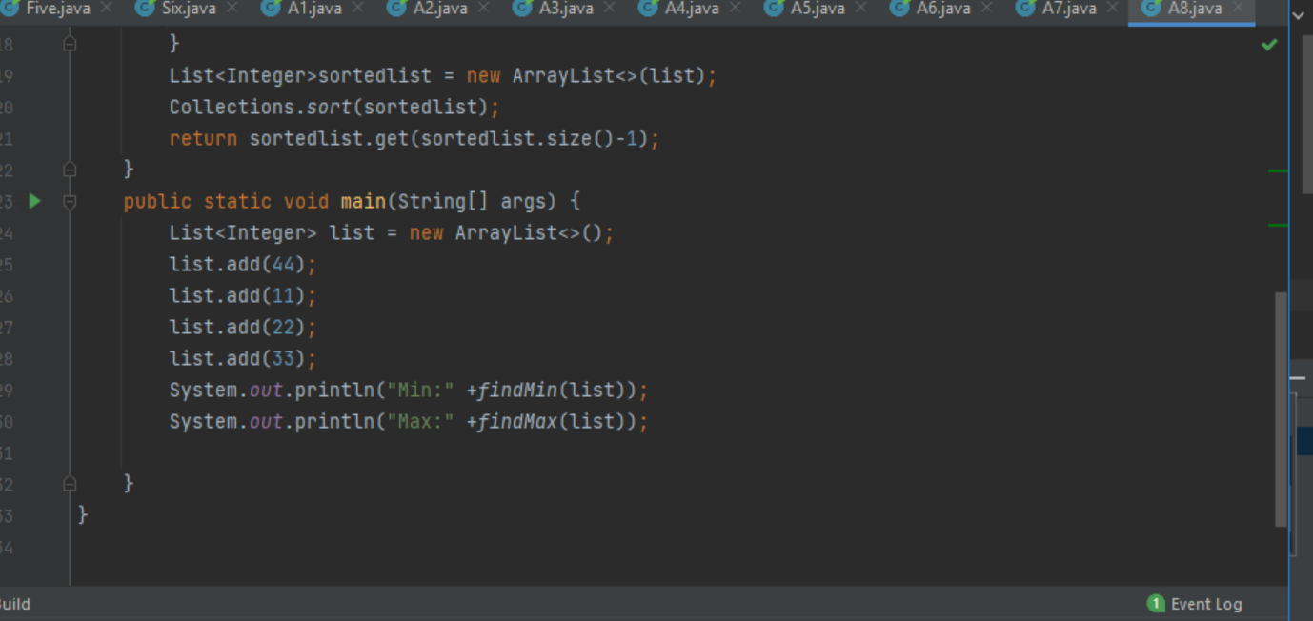

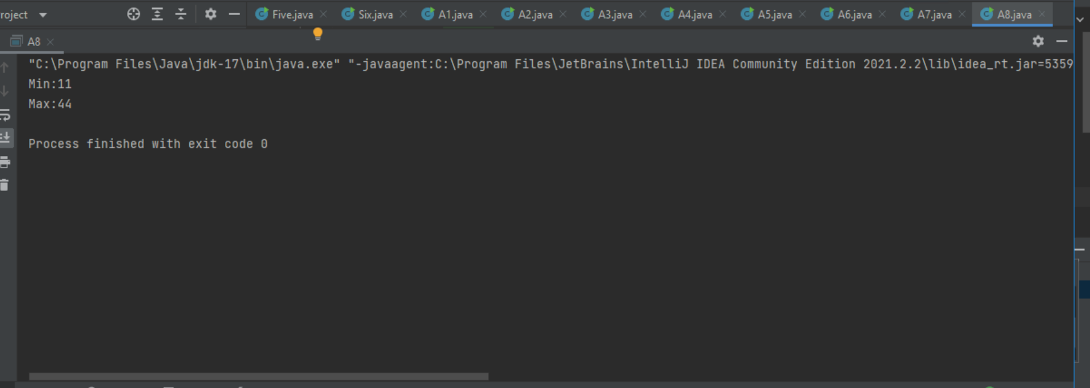

9.WAP to sorting list of string.

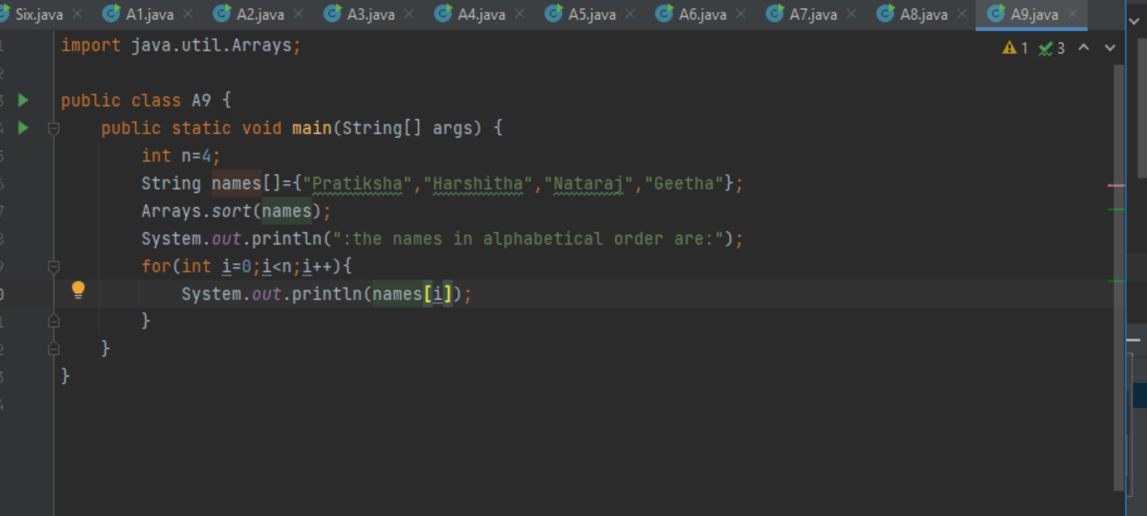

OUTPUT:

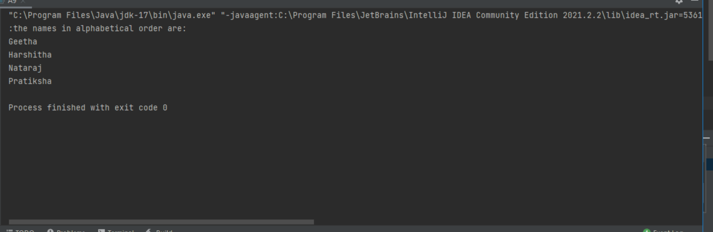

10. WAP to sort list of integers.

